**Tutorial of Mining Sites Detection System**

**Part 1 Image Extraction**

**Wen Li <wenl2@andrew.cmu.edu>**

This is a tutorial on how to apply our program to detect potential mining sites on **Windows.**

**Interface.py and extractImagesFromQGIS.py are in the delivery package.**

# 1. Install Anaconda

* Download Anaconda2 from <https://www.anaconda.com/download/>.
* Click on the package and go through the default installation process until it is installed.

You will see a page like this in the end. It will differ slightly among different versions of Anaconda.

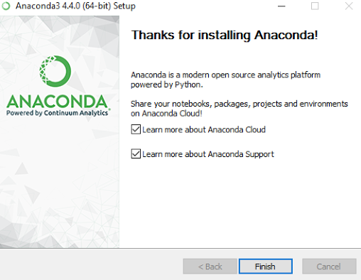

# 2. Install PyCharm

* Download PyCharm 2017.2.3 from <https://www.jetbrains.com/pycharm/>.
* Click on the package and go through the default installation process until it is installed.

You will see a page like this in the end. It will differ slightly among different versions of PyCharm.

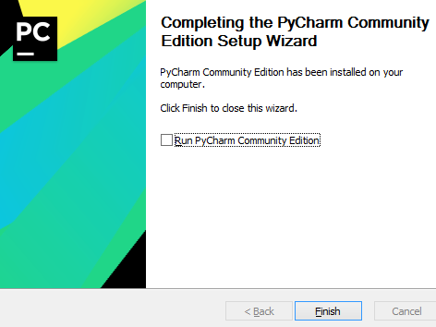

# 3. Install QGIS

* Download QGIS 2.18.13 from <https://www.qgis.org/en/site/>.
* Click on the package and go through the default installation process until it is installed.

You will see a page like this in the end. It will differ slightly among different versions of QGIS.

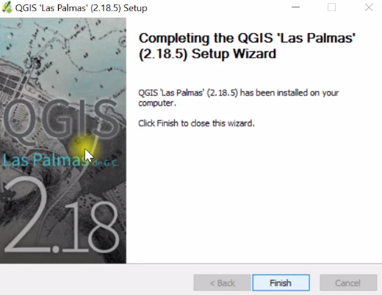

# 4. Run the program

**1. Please make sure any path and filename you input into this system has no “_”.**

**2. Please change the “\”, “\\” in your path and filename to “/” before you input it into the system or modify the code.**

**For example, change “D:\DetectMiningSites\ori.csv” to “D:/DetectMiningSites/ori.csv”.**

## Step1: Create CSV file for coordinates

* Open PyCharm, click “File”, “New Project”, set the location where you put our scripts in and set Anaconda as the interpreter.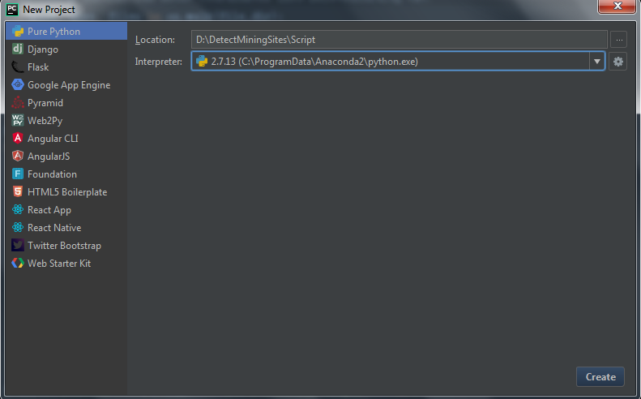

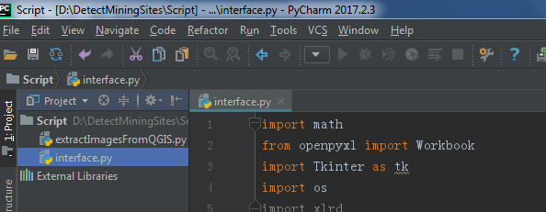

* Wait until the indexing process finish.
* Open “interface.py”, right click it, and click “Run ‘interface’”.

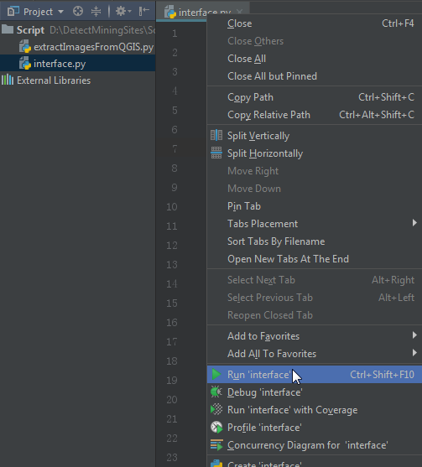

Then you can see the interface of our program.

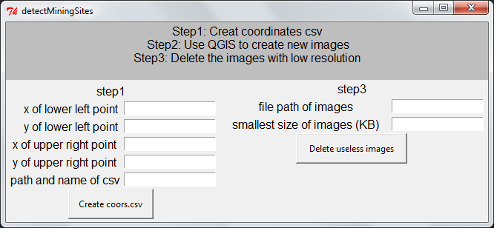

* Create csv for coordinates of the region you want to detect

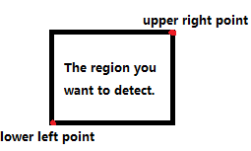

Input the corresponding coordinates and path and name of csv into the interface, then click “Create coors.csv”.

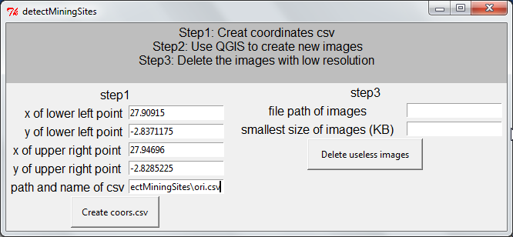

You will find the csv file been created.

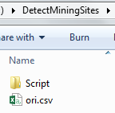

You need to record the path and file this csv file. In this tutorial, it is D:/DetectMiningSites/ori.csv (Referred to as INFO_CSV in the following part).

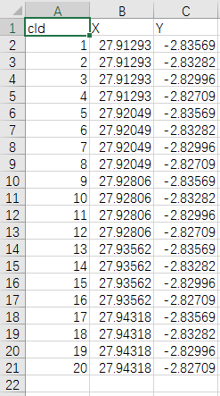

*cId: ID of corresponding coordinates.

You need to record the number of coordinates. In this tutorial, it is 20 (Referred to as NUM_OF_COORDINATES in the following part).

## Step2: Use QGIS to create new images

* Open QGIS, add the basemap you want to use. (Different basemap will have different ways to access, so you need to explore how to import the one you want into QGIS).

In this tutorial, we use Bing Arial Map.

If you want to use this one, you need to install the “OpenLayers Plugin” first: click “Plugins”, then search for “OpenLayers Plugin” and install it.



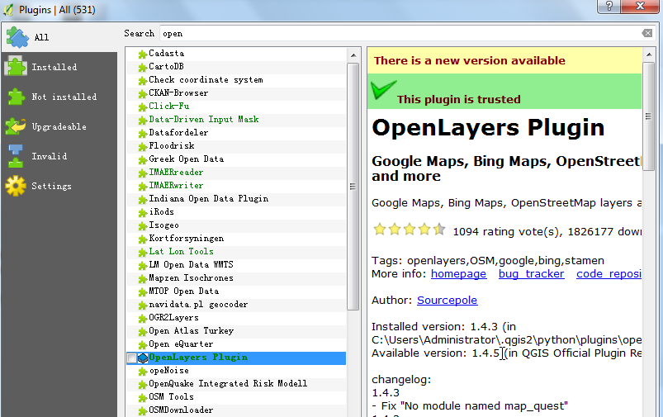

Then click “Web”, “Bing Maps” and “Bing Arial”.

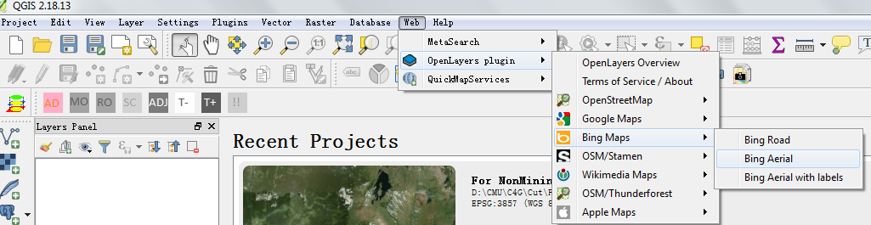

You will see:

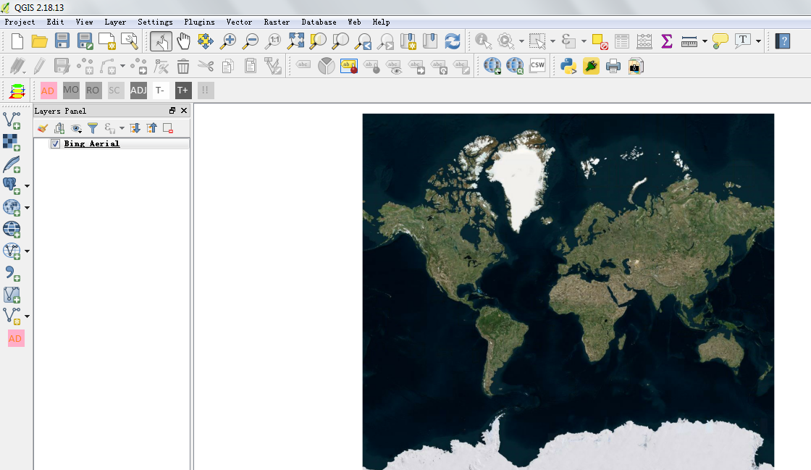

* Then click on the button .

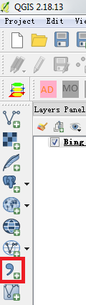

You will see:

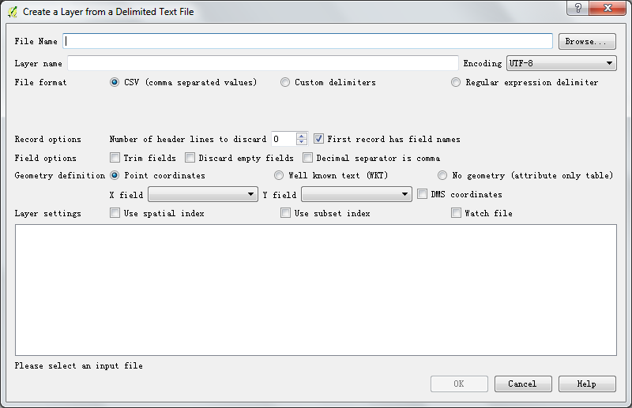

* Click “Browse” and choose the csv file created in the last step.

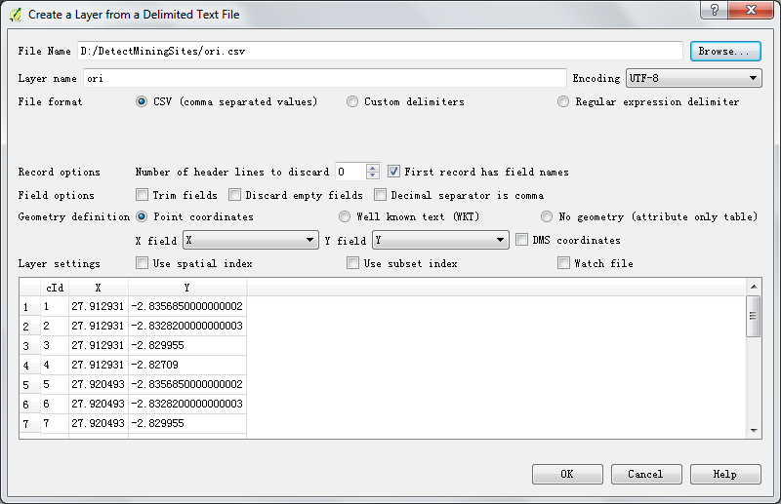

Then click “OK”.

* Choose “WGS86 EPSG:4326” and click “OK”.

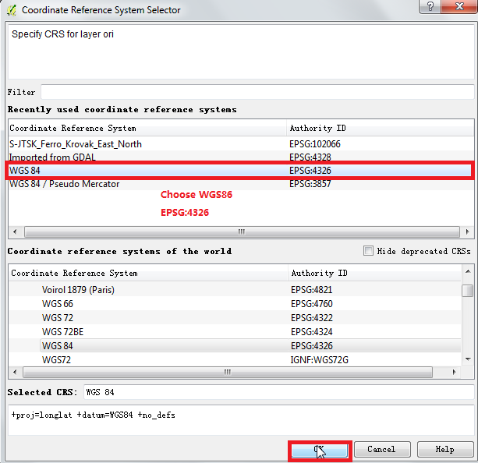

You will see that the two layers are listed in the layers panel.

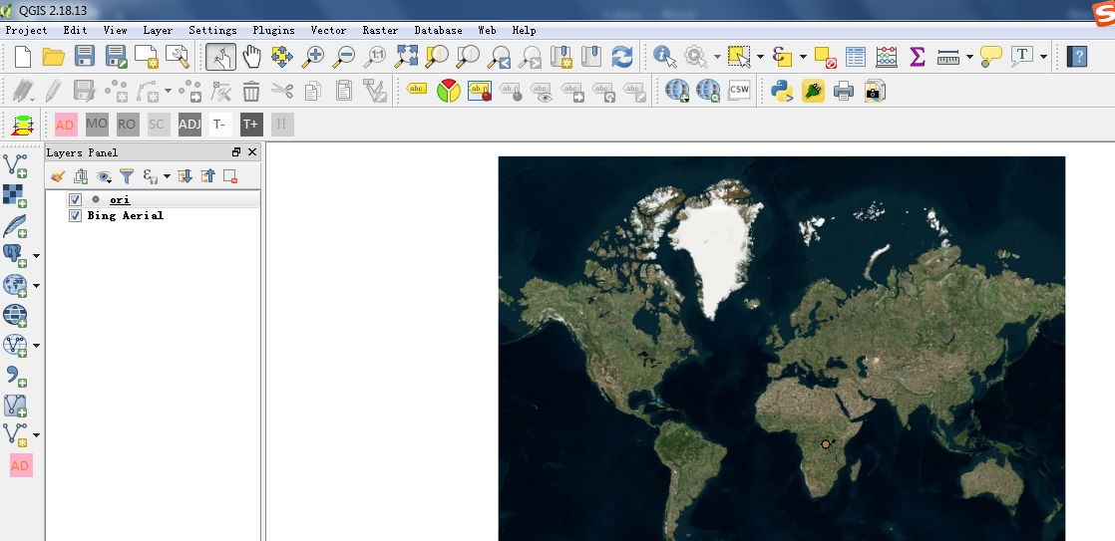

* Right click “ori” in the layers panel, then click “properties”.

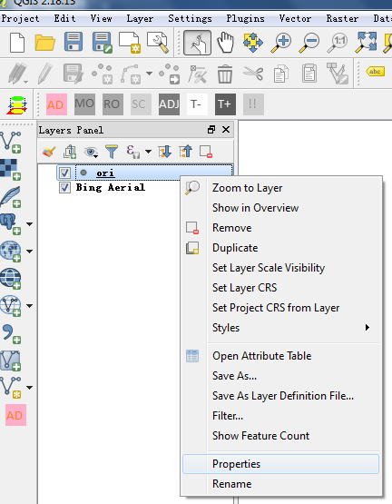

* Click “Style”, then change the layer transparency to 100%.

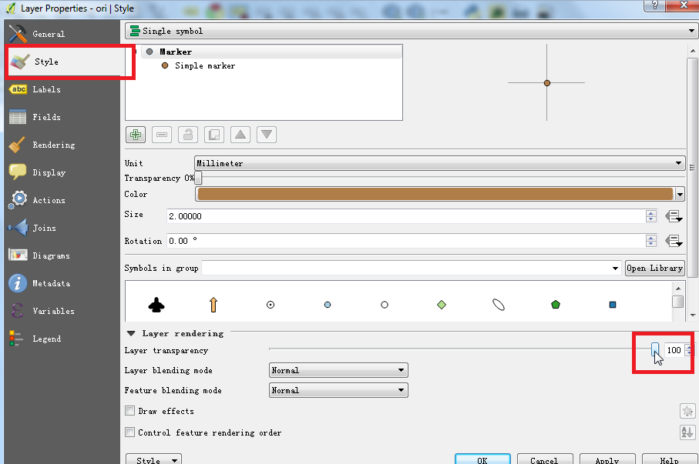

Click “OK”, then you can see:

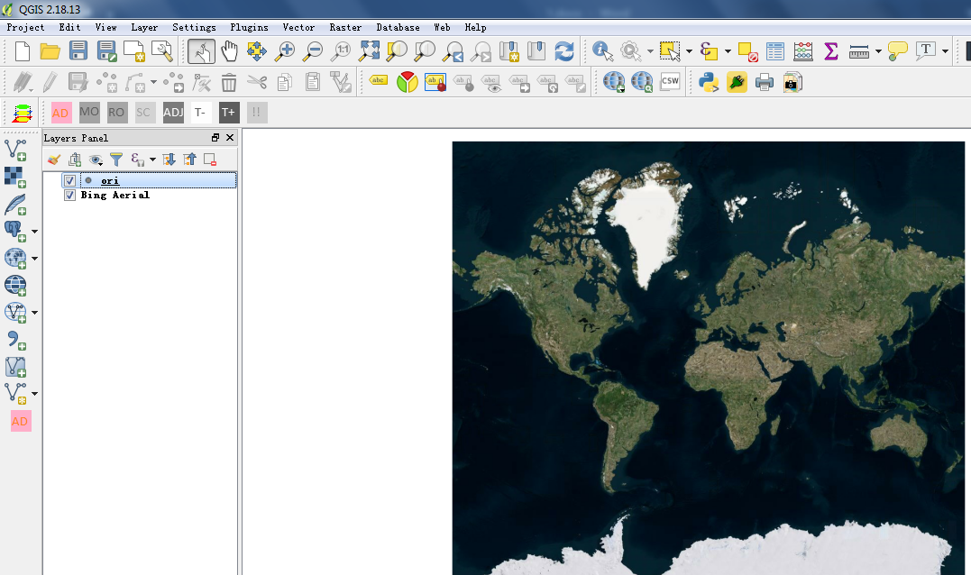

* Click this button: 

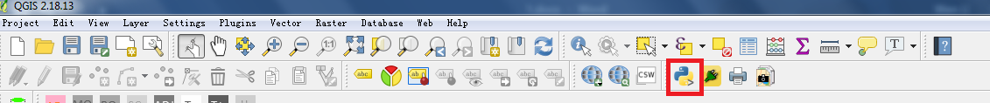

You will see the Python console.

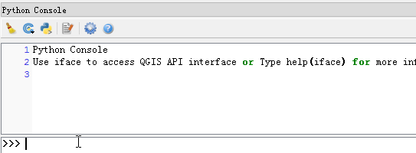

* Open extractImagesFromQGIS.py

Modify three sentences in the script to

1. Inform the folder you want the extracted images to be.

*It should be an empty folder.

You need to record the path of the folder. In this tutorial, it is D:\DetectMiningSites\Images (Referred to as PATH_IMAGES in the following part).

2. Inform the csv file of coordinates (INFO_CSV).

3. Inform the number of coordinates (NUM_OF_COORDINATES).

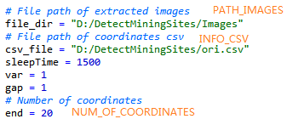

* Copy and paste this script in the Python Console of QGIS.

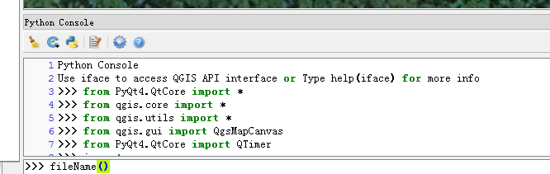

As it runs, you can see the images are being extracted:

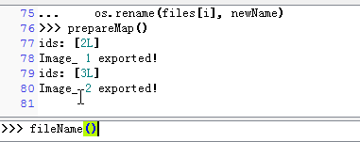

*If the images are empty or not clear enough, you may need to modify these two parameters in the code according to your setting.

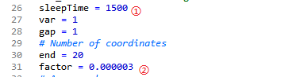

1) ① The system will sleep *sleepTime ms* to handle the next image. You may want to enlarge it so there can be enough time for QGIS to update its canvas.

2) ② You may want to change the zoom factor *factor* to a larger one (if you want the images to be clearer and the basemap is high-resolution enough) or a smaller one (if the basemap is not good enough).

After all NUM_OF_COORDINATES images are extracted, press “Enter” to make fileName() run.

Now, the images can be found in your folder named after the pattern images_No._xCoordinate_yCoordinate.

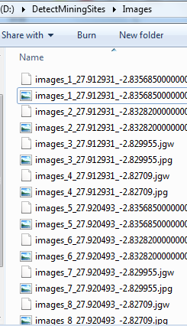

## Step3: Delete low-resolution images

* Input PATH_IMAGES into the interface and set the bar.

*The bar: The smallest size of high-resolution images. The low-resolution images will have an obvious small size, which typically smaller than 220 KB according to our experience.

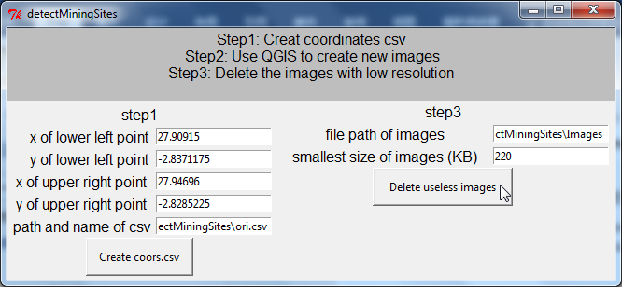

* Click “Delete useless images”

Then useless images will be deleted and their coordinates information will be recorded in DeletedInfoLog.txt in the same folder: 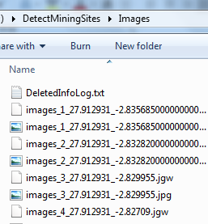

In our tutorial, the DeletedInfoLog.txt is:

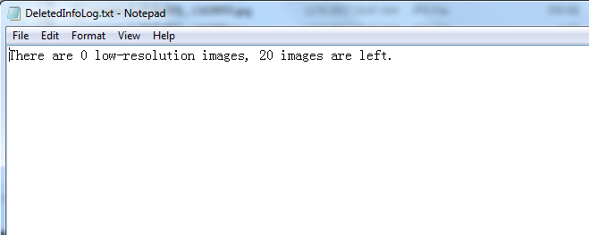

* Now, you get the usable images in your folder!

For more information, please refer to the video demo: https://youtu.be/gyl2uyviCYQ.